IFB102 – Mini Project

Braydan Newman

#### n11272031

Project Objectives

The Goal of the project was to automate the prosses of watering my plants while also making the system smart enogh to not over water and to let me know metrics about the plant and the system, to better inform me on what I should do to take care of the pant.

To make this project how I wanted it have to tick a couple points that realy would make it something usefull:

* Check weather data
* Check soil moister
* Check Water level in tank
* Have it controllable and veiwable without needed to ssh or log into the pi or servers
* Needs to water the plants
* Needs to use the data that has be gathers and make a decion on if the plant should be watered

Review and discussion of Technologes Used

There where many different technolages used for this project

**MQTT**

The conection between the rassberry pi and the Home assistant Server is done using MQTT as its easy to use and works well with home assistant. Mqtt uses a Publish and subscibe method to comunicate between devices and is designed for devices with low conectivity, this works really well for my application as signal strenth on the balchony is very week. Something like a constant socket connection wouldnt work as its higher bandwith and need for a constant connection would make this unreliable and unstable.

The basic premis of a publish subsribe model is that each device can subscribe to a topic and this will allow this devise to hear all data being tansmitted with that as its topic. Where as publishing is the opposite and you publish data with a topic to then be picked up be devices that have subscibed. All the conections are controlled by the Broker and in the project the Home Assistant server is working as the Broker.

Other options I could have used was have a sockets connection to the pi, but this would be unrelaibale as descused before. Another option was run an API end point of both theHome assistant server and the Rassberry pi and uses normal HTTPS as the connection method between them, this could have worked but would have been very involved and would take a lot more time to set up. This method would be much more secure but for my perposes security wasnt a big problem as this is allon a local network with no accese from the outside.

**FTP**

The rasberry pi uses the File Transfer Protocall to send log files to an server running in the cloud, The log files are stored here as good practise measure as data should never be stored in one device and all in one loaction

FTP was the protocall of choice for this application as this protocall is designed for the transfer of files from one server to another.

The Rasberry Pi also has the FTP running on it as this was to upload all the Python scripts used to buils the rest of the application

An alternitive to this could have been the Secure Copy Protocol as this allows the copy of file between 2 remote hosts. This option would have worked just as well as FTP but due to the well documented and easy to use FTP python libery FTB was chosen in favor of SCP

**API**

The Rasberry pi also fetches data from an api serving weather forcast data, this data is used to determine weather to water the plants or hold off and wait for rain.

An API or Applicaton Programming Interface is used by softwear to interface with with other softwear, in this case you send a request to a server endpoint and it sends back weather forcast data.

An alternative to using a weather forcast API is to measure Weather data in real time with sensors connected to the rasberry pi, this approch was considered but due to the increased cost was disregarded, however this will be revisited as loacly sorced data that you have ultiment contol over is normally better.

**Programming Language**

The language I chose was python and all the scripts for the MQTT, FTP and api connection were all done with python, this was chossen as that is the language that im most familler with and most experienced with.

Any other programming language would have worked and have been just as effective, but due to speed not being a concern and pythons great amount of liberies it worked really well for this project

**Eletrical componets**

The Eletrical componets used in the project are a relay, a moister sensor, and a magnet switch.

The relay is used to switch on and off the valve which reqires a higher voltage tand current then the rasberry pi can give it thus through the relay it it connected to a external powersuply, an alternative that could have been used was a MOSFET, This would alow me to switch the current on and off to the vale at the required voltage and current, and it has 0 moving parts making it more resistante to wear and tare. The reason a mosfet wasnt used is thatmy skills in electronics arent as well developed and due to time constants connecting a prebuilt relay circuit was easirer and still got the job done.

The moister sensore is used to test the level of moister in the soil and this sensor gives a analog reading which the rasberry pi can not read. The rasberry pi can only work with digital signals and needs a special chip to convert the analog to a digial signal. In my care the sensore was connected to the pi directly anyway as ifthe sigal was high enough the rasberry pi would interparte that as digital 1. Not the idel solution but one that works and is time efficant.

The magnet switch sensore is used to tell when the water level in the water tank is getting low, this gives an digital reading and work fine for my perpose, any other switch would have worked but this was the easy and effective.

Design and implementaion

Below in a digrame Showing the different connections that where used in the project

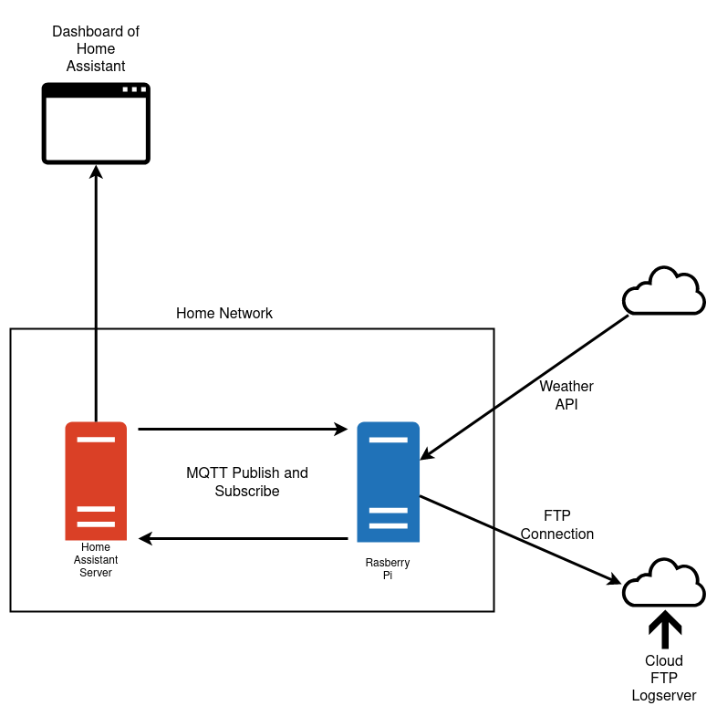

The Troubles faced during this project where limited to only a couple of notable times, one of these was getting home assitante running on a old laptop that I had laying around, I initaly tried to run the home assistante OS but due to unkown reasons the laptop would not boot with this os installed and had to more to different aproch on install Ubuntu server and Building home assistante ontop of this. But after this home assitant worked perfectly with no trouple. The other issue was with cron and was finicky and took some trail and error to run relablie. No other issues where faced exept for time managemnt but that was due to me.

The next step fro this project is to clean up the code, encloser and mounting solution for the varios componets. After this is would like to be able to acceses the dashboard from outside my loacal network andfrom my domain name and this is relativly easy and just requieres time. This would help make the project more usefull and user friendly.

Over View of code

One python scripts runs continuosly lisenting for any publishes on any of the subsribed topics this then runs seprate sripts depending on the message, if the message is water, it will run a script which handels the watering time. Another section is a script that every 5 secons retrives the current value from the sensors and publishes the data on certin topic tobe picked up by home assistant. Another script is run my a cron job to check weather and the sensors and determins if the pants should be watered this then runs the water script depending on if the sript determins. This scrip will also run the ftp scrip which send all the logs to the ftp server.

Refrances